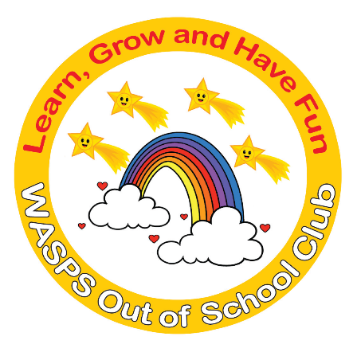
WASPS Out of School Club
A warm and safe environment where children aged 2 to 13 learn, grow and have fun!

Data Protection Policy
At WASPS Out of School Club we respect the privacy of the children attending the Club and the privacy of their parents or carers, as well as the privacy of our staff. Our aim is to ensure that all those using and working at WASPS Out of School Club can do so with confidence that their personal data is being kept secure.
Our lead person for data protection is Nicola English. The lead person ensures that the Club meets the requirements of the UK GDPR, liaises with statutory bodies when necessary, and responds to any subject access requests.
Confidentiality
Within the Club we respect confidentiality in the following ways:
- We will only ever share information with a parent about their own child.
- Information given by parents to Club staff about their child will not be passed on to third parties without permission unless there is a safeguarding issue (as covered in our Safeguarding Children (child protection) and E-safety policies).
- Concerns or evidence relating to a child’s safety, will be kept in a confidential file and will not be shared within the Club, except with the Designated Safeguarding Lead and the manager.
- Staff only discuss individual children for purposes of planning and group management.
- Staff are made aware of the importance of confidentiality during their induction process.
- Issues relating to the employment of staff, whether paid or voluntary, will remain confidential to those making personnel decisions.
- All personal data is stored securely on a password protected computer.
- Students on work placements and volunteers are informed of our Data Protection policy and are required to respect it.
Information that we keep
The items of personal data that we keep about individuals are documented on our personal data audit. The personal data audit is reviewed annually to ensure that any new data types are included. This is kept in our UK GDPR file.
Children and parents: We hold only the information necessary to provide a childcare service for each child. This includes child registration information, medical information, parent contact information, attendance records, incident and accident records and so forth. Once a child leaves our care, we retain only the data required by statutory legislation and industry best practice, and for the prescribed periods of time. Electronic data that is no longer required is deleted and paper records are disposed of securely.
Staff: We keep information about employees in order to meet HMRC requirements, and to comply with all other areas of employment legislation. We retain the information after a member of staff has left our employment for the recommended period of time, then it is deleted or destroyed as necessary.
Sharing information with third parties
We will only share child information with outside agencies on a need-to-know basis and with consent from parents, except in cases relating to safeguarding children, criminal activity, or if required by legally authorised bodies (eg Police, HMRC, etc). If we decide to share information without parental consent, we will record this in the child’s file, clearly stating our reasons.
We will only share relevant information that is accurate and up to date. Our primary commitment is to the safety and well-being of the children in our care.
Some limited personal information is disclosed to authorised third parties we have engaged to process it, as part of the normal running of our business, for example in order to manage our payroll and accounts. Any such third parties comply with the strict data protection regulations of the UK GDPR. In accordance with Section 124 of the Police Act 1997, disclosure information is only passed to those who are authorised to receive in in the course of their duties.
Subject access requests
- Parents/carers can ask to see the information and records relating to their child, and/or any information that we keep about themselves.
- Staff and volunteers can ask to see any information that we keep about them.
- We will make the requested information available as soon as practicable, and will respond to the request within one month at the latest.
- If our information is found to be incorrect or out of date, we will update it promptly.
- If any individual about whom we hold data has a complaint about how we have kept their information secure, or how we have responded to a subject access request, they may complain to the Information Commissioner’s Office (ICO).
UK GDPR
We comply with the requirements of the General Data Protection Regulation (UK GDPR), regarding obtaining, storing and using personal data.

This policy was adopted by: WASPS Out of School Club | Date: August 2023
To be reviewed: August 2024 | Signed: Nicola English
Written in accordance with the Statutory Framework for the Early Years Foundation Stage (2021): Safeguarding and Welfare requirements: Information and records [3.69-3.73]

