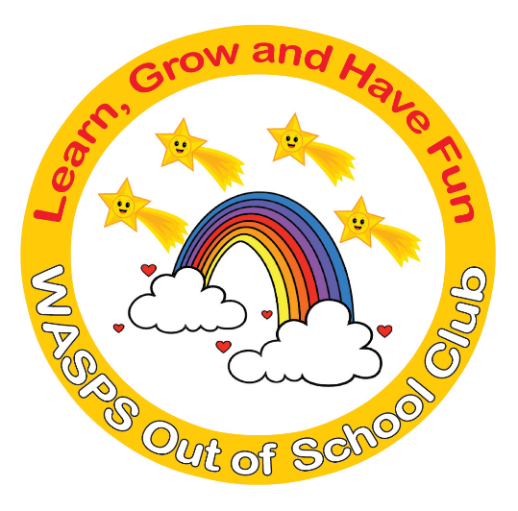
WASPS Out of School Club
A warm and safe environment where children aged 2 to 13 learn, grow and have fun!

Terms and Conditions
Our Mission Statement
We aim to provide a happy, safe, warm and stimulating environment for all children to play, learn and develop freely. We help children to develop responsibility for themselves and their actions and to become competent, independent and co-operative individuals. Playwork is about children learning through play and having fun at the same time.

Our Club aims:
- Encourage children to have a positive attitude and respect for both themselves and other people.
- A programme of activities that is interesting, educational, stimulating and fun and that put the needs and safety of children first.
- Activities that promote each child’s social, physical, moral and intellectual development.
- Access to a variety of facilities and equipment under safe and supervised conditions.
- A staff team that is experienced, well trained and properly supported.
- Services that meet the conditions of the Children’s Act 1989 and all other relevant childcare legislation, wherever they apply.
- An environment free from bullying and discrimination in any form.
- Promote a positive relationship with parents/carers and work in partnership with them to provide high quality play and care for their children by listening and responding to their views and concerns.
- Offer inclusive services that are accessible to all children in the community.
Bookings
- All bookings must be made through https://waspsclub.magicbooking.co.uk
- All bookings are subject to availability.
- The person making the booking accepts the booking conditions on behalf of the account holder
- All bookings must be paid for at time of booking unless card instalment plan is selected at time of booking or you are paying by Childcare Vouchers/Tax Free Childcare.
- If payment is not received before a child/children are due for a session then the child/children will not be allowed to attend that session until payment has been received from the parent/carer.
Cancellation Notice and Charges:
- It is the account holder’s responsibility to cancel sessions.
- Any booked sessions which are not attended are still charged.
- Parents must inform the club by email if their children are arriving late at after school club due to attending an extra-curricular club.
- For Breakfast and After School clubs we are not able to swap sessions for other dates but we can book extra sessions for you.
- All bookings and payments must be made prior to arriving onsite. If you arrive at a site and have not booked and paid, your child will not be accepted.
- It is the parents’ responsibility to inform the school if their child is attending after school club.
- It is the parents’ responsibility to let the school know of any late cancellations.
- It is the parents’ responsibility to ensure WASPS Out of School club has been informed of any absences. Failure to notify will incur an extra charge of £2.
Payments and Overdue Balances
- Types of payment available are Credit/Debit card, Childcare Voucher, 30 hour childcare funding or Tax Free Childcare.
- When paying by Childcare Vouchers or Tax Free Childcare, please use your child’s full name as the payment reference.
- Having an overdue balance may lead to the termination of your child’s place within the club.
- Fees are due by the 1st of the month at the latest in advance. Any parents that have a problem with this date, need to speak to the club otherwise a stop will be put on their account if in arrears.
- WASPS Out of School Club will pass any unrecovered fees to an external debt collection agency. Any fees associated with the debt collection will be passed on to the debtor.
Late Collection Fees:
A charge of £15 per 15 minutes will be applied to all collections made after the advertised session end time. This relates to 6.15pm during term time and 6.00pm during holiday play schemes. If you are going to be late, please let us know. If you do not inform us that you are going to be late, please be aware that after 30 minutes our Uncollected Child Policy comes into force and we will contact Social Services for advice.
Safeguarding and Welfare:
- If your child does not arrive at a booked After School Club session and we have not been advised of their non-attendance by you the parent, we will begin our Missing Child Procedure.
- We are committed to safeguarding all the children in our care from harm and abuse.
- WASPS Out of School Club are obligated to report any suspected child abuse or neglect to the relevant authorities.
- Parents must inform WASPS Out of School Club of any conditions that may affect their child (medical, learning, behavioural, etc). If full information is not provided, this may result in WASPS Out of School Club excluding them from certain activities or if it felt necessary, excluding them from using WASPS Out of School Club. In such circumstances no refund or credit will be paid.
Collecting:
- Children can only be collected by an adult over the age of 16 who has been authorised to collect them which is done by the parent adding collectors on their account as a collector.
- It is the parents’ responsibility to ensure that they inform the club of anyone else that may be collecting their child and request a password for that collection.

Sickness:
- Parents/carers are required to keep their children at home if they are unwell and to inform us of the nature of the illness.
- Any infectious disease that a qualified medical person considers notifiable will be notified to Ofsted.
- Any child who feels ill or in distress will be comforted and the illness assessed. If a child’s illness may be contagious, we will be aware of their environmental and personal hygiene and they will be isolated from the other children if necessary.
- Parents/carers will be informed by telephone and will be required to collect their child immediately.
Medication:
If your child requires medication of any sort, including an inhaler, the following must be in place before your child can attend:
- Completed Health Care Plan, please contact the club who will email this to you.
- Permission to Administer medication form, please contact the club who will email this to you
- Our own supply of medication at the club – we have no access to any medication stored in school
Please note: If the above is not in place, your child will not be able to attend the session
Notice Period:
- WASPS Out of School Club request 4 weeks’ notice in writing to cancel a child’s place permanently. Payment of the invoice will still need to be paid for this notice period.
- To book an extra/ad hoc session not on your current recurring contract, WASPS Out of School Club requests 2 days’ notice. Failure to do so will incur an extra charge of £2.
- To cancel any recurring session WASPS Out of School Club requests 1 days’ notice. Failure to do so will incur an extra charge of £2. The exception to this rule will be if a child is not attending due to illness. This will need to be communicated to the club in writing so as not to incur an extra fee for short notice cancellation.
- WASPS Out of School Club reserve the right to exclude a child from WASPS with less than 24 hours’ notice if they persistently bullies or behaves aggressively towards another child or a member of staff. The parent will be asked to come in for a meeting with the Proprietor.
Exclusion:
- WASPS Out of School Club reserves the right to exclude or refuse any person without notice, if we consider that their presence compromises the good atmosphere of the club. Transport home will be the responsibility of the parent and no refund/credit will be available.
Forced Closures:
- If WASPS Out of School Club is forced to close due to an external factor such as bad weather, infectious or contagious disease outbreak, Power cut, Teacher Strikes or other industrial action, by order of Local Authority or Environmental Health, customers will still be liable for fees incurred during the entire period of closure. Any credit is at the discretion of the Proprietor.
Schedule Changes:
- WASPS Out of School Club may need to amend activity programmes, schedules, services, dates, times and/or venues on occasions that may be out of our control. This will be without refund or compensation to the customer.
Photography:
- WASPS Out of School Club occasionally take photographs and videos at our venues which can be used for marketing and promotional purposes, including on social media. If you would rather your child was not included in any photographs, please ensure your child’s details are up to date.
Complaints:
- If you or your child were not entirely satisfied with the services we provided, we would appreciate the feedback. Please see our complaints procedure for official steps. If you feel the complaint outcome is insufficient or would like to escalate your grievance further, please email The Proprietor, Nicola English at WASPS Out of School Club on nicola@waspsclub.com.
Liability:
- WASPS Out of School Club does not accept liability for personal injury or death of any participants unless directly caused by the proven negligence of the company or its servants.
- WASPS Out of School Club take no responsibility for any items that are lost/stolen or damaged at the club.
Lost Property:
- On request, WASPS Out of School Club will endeavour to return items that can be identified. Unclaimed Breakfast and After School Club lost property will be distributed to local schools or charities at the end of each half term. Holiday Club lost property will be distributed to local schools and charities two weeks after the school holiday.
Parent Abuse of staff:
- The threat or use of physical violence, verbal abuse, intimidation or harassment towards our staff is likely to result in a termination of all direct contact. Such incidents may be reported to the police and this will always be the case if physical violence is used or threatened.
Data Protection:
- WASPS Out of School Club collect personal details for you and your child to register and enable us to process your booking. It is your responsibility to ensure that you have the necessary permission to pass on the personal details of everyone required. WASPS Out of School Club may hold some of your details for future marketing purposes. Please let us know if you do not want to receive future communication from WASPS Out of School Club.
- For a copy of any of WASPS Out of School Club policies and procedures, please email nicola@waspsclub.com
- Parents must agree to the terms and conditions of our booking system to book with us.

This policy was adopted by: WASPS Out of School Club | Date: August 2023
To be reviewed: August 2024 | Signed: N J English  (Proprietor)

