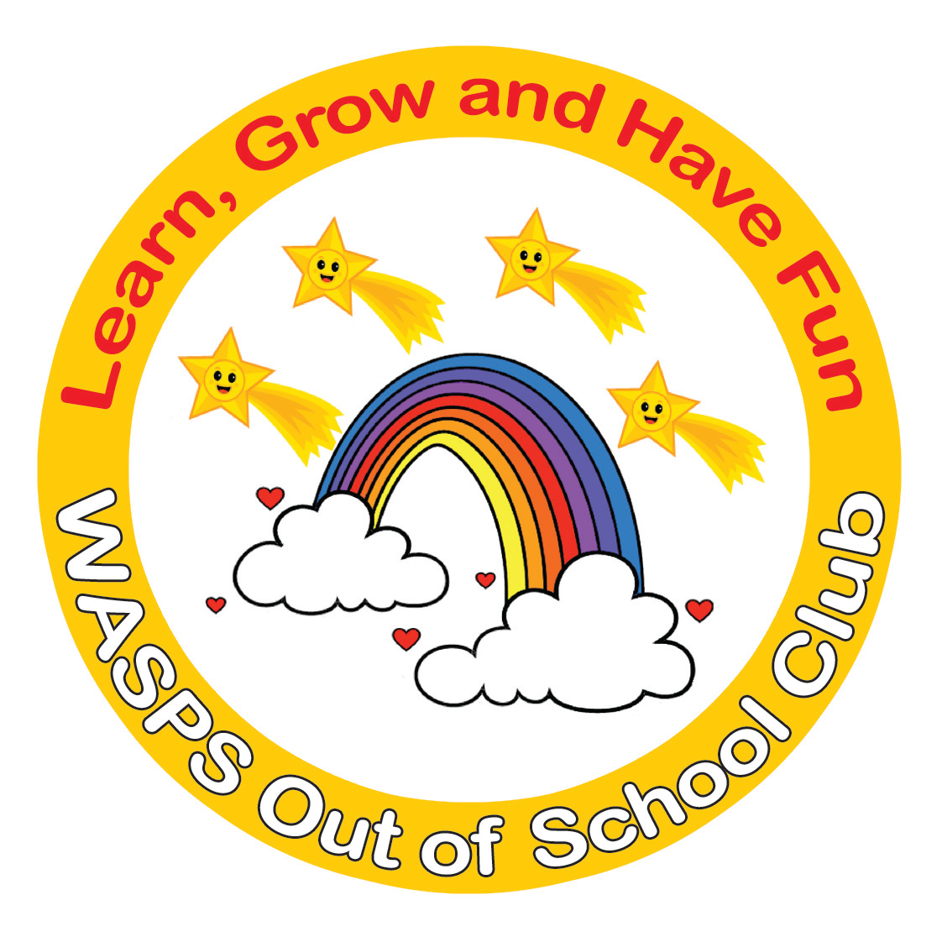
WASPS Out of School Club
A warm and safe environment where children aged 2 to 13 learn, grow and have fun!

Uncollected Children Policy

WASPS Out of School Club has the highest regard for the safety of the children in our care – from the moment they arrive to the moment that they leave.

At the end of every session, the Club will ensure that all children are collected by a parent, carer or designated adult, in accordance with the Arrivals and Departures policy. If for some reason a child is not collected at the end of a session, the following procedures will be activated.

1. If a parent, carer or designated adult is more than 15 minutes late in collecting their child, the Manager will be informed. The Manager will call the parent, carer or designated adult, and use all emergency contact details available in order to try to ascertain the cause for the delay, and how long it is likely to last. Messages will always be left on any answer phone requesting a prompt reply.
2. While waiting to be collected, the child will be supervised by at least two members of staff to ensure the Safeguarding Children and E-Safety Policy is adhered to, who will offer them as much support and reassurance as is necessary.
3. If, after repeated attempts, no contact is made with the parent, carer or designated adult, and a further period of 30 minutes has elapsed, the Manager will contact social services for advice.
4. In the event of the social services being called and responsibility for the child being passed to a child protection agency, the Manager will attempt to leave a further telephone message with the parent/carer or designated adults’ answer phone. Furthermore, a note will be left on the door of the Club’s premises informing the parent, carer or designated adult of what has happened. The note will reassure them of their child’s safety and instruct them to contact the local social services department.
5. Under no circumstances will a child be taken to the home of a member of staff, or away from the Club’s premise in the course of waiting for them to be collected at the end of a session.
6. The child will remain in the care of the Club until they are collected by the parent, carer or designated adult, or alternatively placed in the care of social services.
7. Incidents of late collection will be recorded by the Manager and discussed with parents/carers at the earliest opportunity. Parents and carers will be informed that late collection will result in the imposition of a fine of £15 per child per 15 minutes or part thereof to partly cover the cost of extra hall hire and staff wages. Continued late collection of children may mean the loss of their child’s place at the Club.

This policy was adopted by: WASPS Out of School Club | Date: August 2024
To be reviewed: August 2025 | Signed: N J English  (Proprietor)
Written in accordance with the Statutory Framework for the Early Years Foundation Stage (2024): Information about the Child [3.73]

